**Standard Operating Procedure**

**Gas Welding**



**ODISHA MINING CORPORATION LTD.**

**KODINGAMALI BAUXITE MINE**

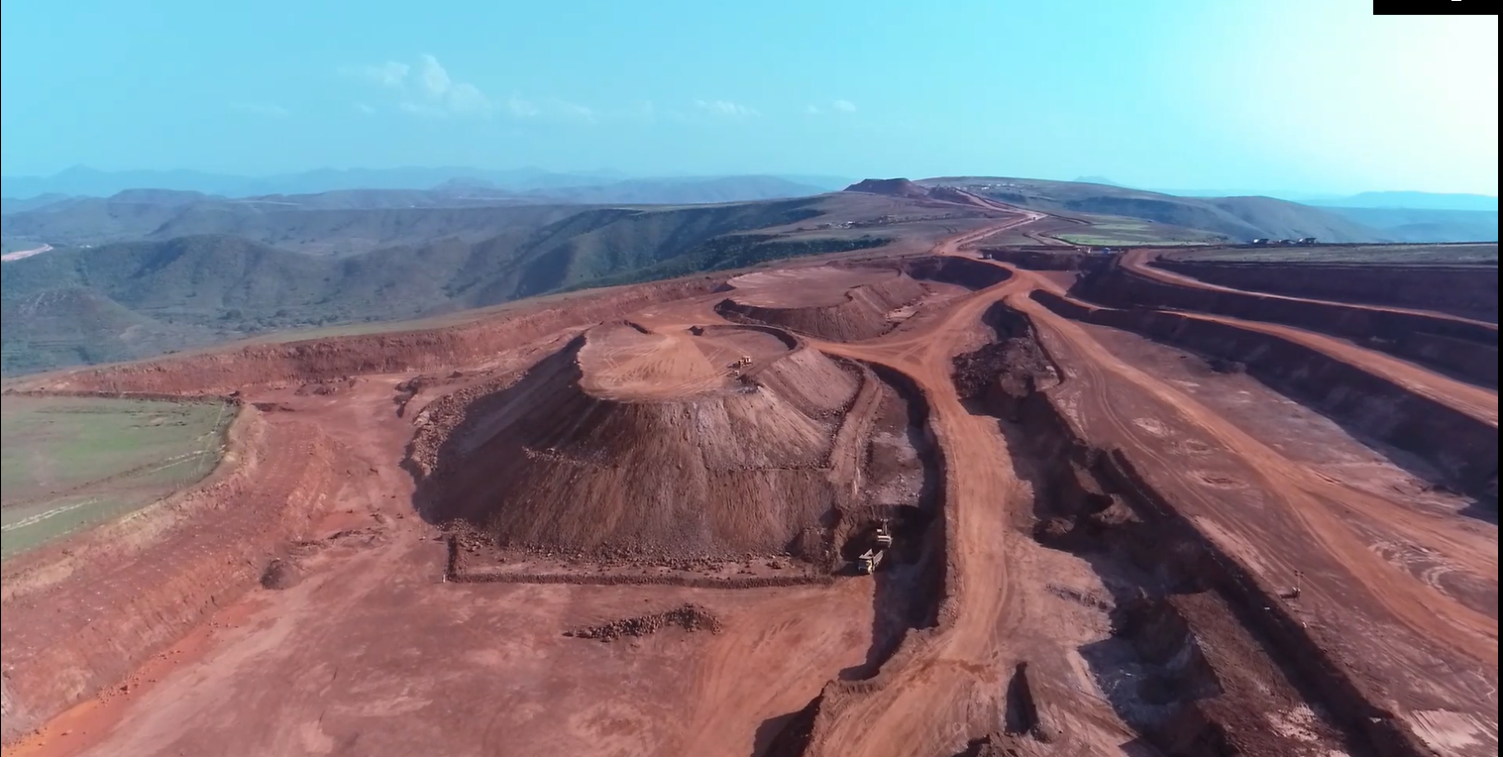

**Authorized By**

**Purpose:** The SOP shall be followed where Gas cutting activity will be carried on & to prevent work men from the hazards arises out from the Gas cutting.

**Scope:** The Procedure is applicable to all areas of loading point, site workshop& Mines where Arc Gas Cutting activities will be carried on.

**Procedure:**

|  |
| --- |
| 1. Use specified shielding devices and other PPE of correct specifications. 2. Move out any leaking cylinder. 3. Keep cylinders in vertical position 4. Use trolley for transportation of cylinders and chain them 5. Use flashback arrestors 6. Purge regulators immediately and then turn off 7. Never use grease or oil on oxygen lineconnections and copper fittings on acetylene lines 8. Inspect regularly gas carrying hoses 9. Always use red hose for acetylene & other fuel gases and black for oxygen 10. Always stand back from the regulator while opening the cylinder 11. Turn valve slowly to avoid bursting Cover the lug terminals to prevent short circuiting 12. Empty & purge them before welding 13. Never attach the ground cable to tanks, container or pipe storing flammable liquids 14. Never use LPG for gas cutting 15. Oxygen cylinders should not be stored near other cylinders containing gas or oil, grease or other combustible materials. 16. Before cylinder is moved, the cylinder valve must be closed. 17. Gas cutting torches should be lighted by means of friction flames or similar other methods only. 18. When torches are being changed or welding stopped for short time, all cylinders valve must be closed. 19. Hot work permit to be taken during job execution. 20. All DA cylinders should be kept in upright position whenever in use or while storing. Oxygen cylinder should, however, be kept flat on the ground only when in use. 21. The unloading and loading of gas cylinders must be carried out with utmost care, cylinders should not be allowed to drop or come into violent contact with one another. Rolling of gas cylinders should be avoided and they should be transported by proper trolleys. 22. Application of oil, grease or any other lubricating materials to regulations, valves or fittings of gas cylinder is strictly prohibited to avoid ignition and explosion. 23. In case of leakage from regulators, valves or other fittings of gas cylinders, the cylinders should not be used and removed from the site. 24. Suitable fire extinguishers in working condition should be available at every work site. |